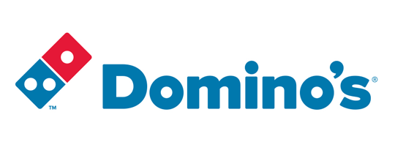

\

|  |
| --- |
| **Domino’s Supply Chain Case Study** |
|  |

|  |  |
| --- | --- |
| **By:** Sarah Al-Sharif Milkias Demissie  Ali Khazaei Casey Valentine Steven Charbonneau Karla Hoffman |  |

# Pizza in America

Pizza is one of America’s favorite foods. The average American consumes at least one slice per month and in total, Americans consume over three billion pizzas per year. The pizza industry was one of the fastest growing food market segments in the country with 2016 sales topping $44 billion dollars [1].

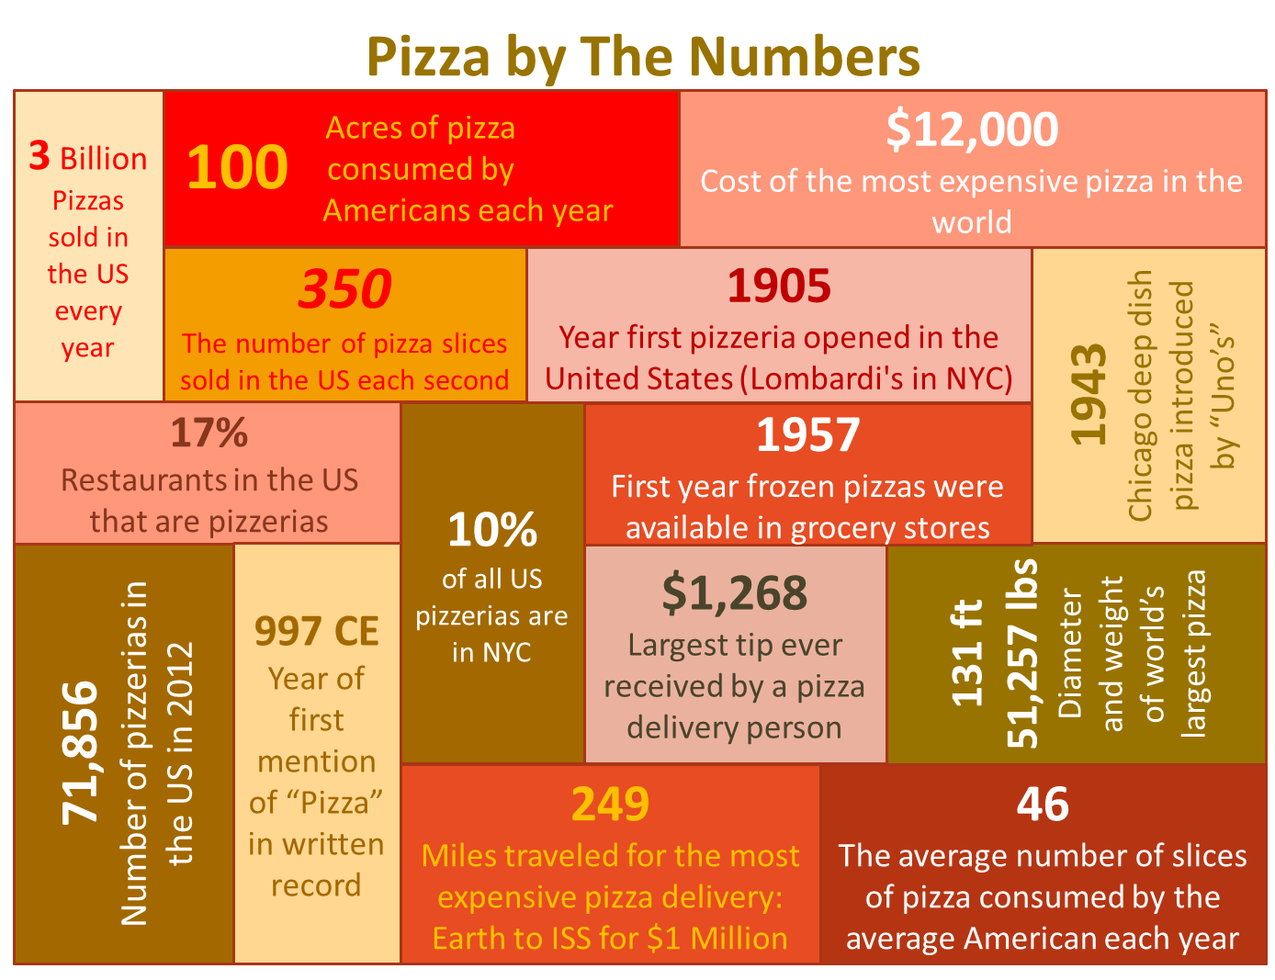

Figure 1: Pizza by the Numbers

Pizza was introduced from Sicily, Italy to the United States in 1905 by the Italian immigrant populations in New York City and Chicago. The pizza industry exploded after World War II with U.S. soldiers from Italy returning home after being introduced to pizza. The pizza industry consisted of family owned businesses until 1958 when Dan and Frank Carney decided to franchise their Wichita, Kansas based Pizza Hut [2]. By 1966, Pizza Hut had expanded to 145 stores nationwide and in 1968 began franchising internationally with their first store in Canada [3]. Following on the heels of Pizza Hut, Little Caesar’s Pizza began franchising in 1959 while Domino’s began franchising in 1967. Papa John’s is the most recent mega franchise that entered the market in 1983. Together the top four pizza franchises have over 19,000 stores and account for just over 25% of the US market with independent stores still dominating 54% of the market space [4].

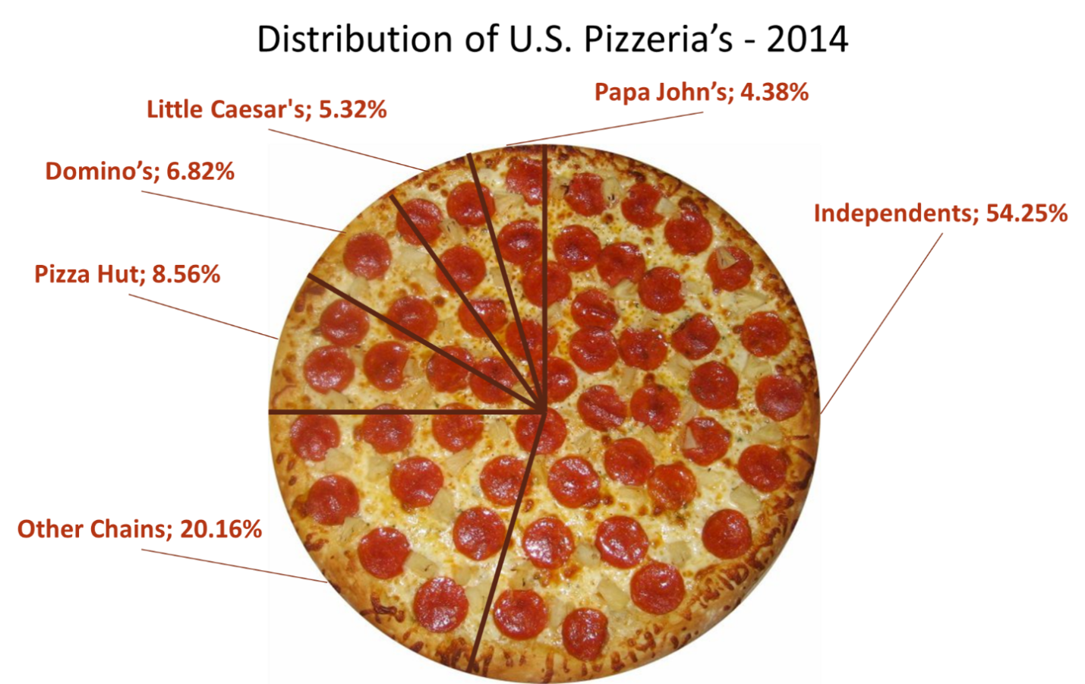

Figure 2: 2014 Distribution of U.S. Pizzeria’s

The pizza franchising industry has thrived in a market dominated by independent stores due to the competitive advantage of purchasing power and the ability to demand discounts from ingredient suppliers. Large chains buy ingredients for their entire franchise in bulk taking advantage of volume discounts and bargaining power with suppliers while independents and small chains are forced to pay market price. Franchises also have competitive advantage in acquiring and maintaining customers due to brand recognition, product familiarity, and economies of scale in marketing. These competitive advantages are realized through the development and leverage of complex supply chains optimized to reduce product costs and enhance profit margins. This allows franchise stores to acquire the ingredients to make one pizza consisting of dough, tomato sauce, and cheese for a price of just over $4. This price includes material cost, profit, labor cost, transportation cost, royalty, and ad contribution costs [5]. Each franchise has its own agreements with providers and distributers that drive its own profit margins. This case study investigates the supply chain logistics associated with the Domino’s Pizza Chain.

# The Birth of Domino’s

In 1960, Tom Monaghan at the age of 23 purchased DomiNick’s Pizza in Ypsilanti, Michigan for $1,400 with his brother James. James did not wish to quit his job as a postman so eight months later Tom traded a used Volkswagen Beetle for James’ stake in the company. Tom expanded his business by purchasing two other pizzerias in Ypsilanti and in 1965 tried to rename his two newest stores to DomiNick’s to improve branding but was denied by the original owner. A delivery driver working for Tom suggested Domino’s. Tom liked it and that became the name of the stores and business[6].

Growth for Domino’s was staggering. In 1967 Domino’s Pizza began franchising in Michigan, in 1968 Domino’s franchised its first store outside of Michigan (Burlington, VT), and franchised its first international store (Winnipeg, Canada) in 1983. Domino’s opened its 200 store by 1978, its 1,000 store by 1983, and its 5,000 store by 1989. In 1998, Tom retired from Domino’s at the age of 61 selling 93% of the company to Bain Capital, Inc. for $1 billion [7].

By 2016, Domino’s had 5,200 stores (*for this case study you will use approximately 4,800 stores*) in the US and over 7,330 stores in over 80 foreign markets. Of the 12,530 stores only 384 are owned by Domino’s. It is the second largest pizza chain in the world [30].

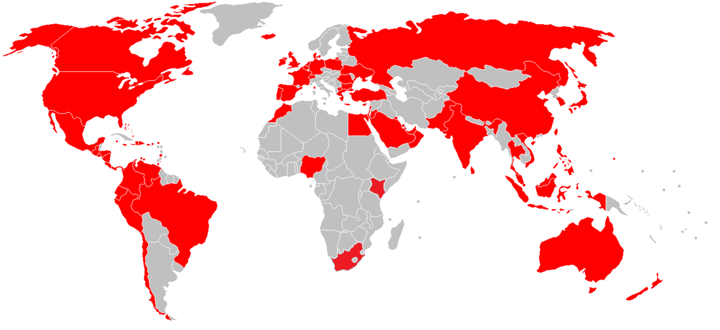

Figure 3: Countries with Domino’s Pizza

# Domino’s Supply Chain

In 2015, Domino’s generated $2.2 billion dollars of revenue of which 62% percent was from supply chain management [8]. Although most of us think of Domino’s as a pizza company, the company is actually a logistics company. Domino’s Supply chain is divided into three main tiers. Tier2 is comprised of Domino’s key suppliers to its regional distribution centers. Tier 2 includes nine Leprino’s foods cheese suppliers, three Paradise tomato sauce suppliers, thirty eight Ardent Mills flour supplier and two Domino’s thin crust and veggie supplier centers. Tier 2 supplies pizza toppings, cheese, tomato sauce, flour, and thin crust to Tier1 (Domino’s regional distribution centers). These regional distribution centers provide supplies directly to the stores (Tier 0). There are 16 Domino’s regional distribution centers.

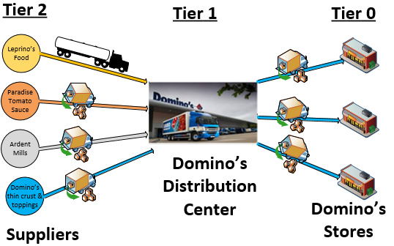

Figure 4: Domino’s Supply chain tiers

In order to control the quality standards of its products, Domino’s has strict requirements on ingredients, assembly, and cooking of its products. To maintain quality standards, the company requires franchise stores to purchase the dough, cheese, and sauce from its corporate distribution centers. Dough is made at the distribution centers to further ensure consistency and reduce preparation activities at stores. The distribution centers also sell toppings, equipment and other restaurant consumables like boxes and cleaning supplies but does not require franchisees to purchase these items from the distribution centers.

## The Domino’s Pizza Supply Chain Case Study

The Domino’s supply chain and distribution system case study will be used as a means for teaching, improving, and refining your skills in the application of linear programming. Much of the details and data associated with this case study have been consolidated from publically available data. Where not available, some details have been assumed to define the problem and some detailed data have been created (fabricated) to be consistent with stated or assumed parameters. Unless a specific citation has been referenced regarding a “fact” associated with the case study, readers should assume the fact was fabricated. Not all information required to solve the problem is provided. You will be required to do research to find some of the information required to solve this problem.

In the conduct of this case study you will:

* Formulate, model, and solve large scale transportation and facility location problems using Linear Programming (LP), and Integer Programming (IP) models,
* Manage and manipulate large data sets and transform them into parameters used by your LP formulation.

## Distribution Centers

Domino’s has 18 distribution centers, 16 of which supply all Domino’s stores with necessary pizza ingredients and other store consumables. These 16 Domino’s distribution centers supply dough, cheese, sauce and thin crust bread. Stores receive shipments from these 16 distribution centers twice per week. Domino’s also operates two specialized distribution centers that manufacture thin crust pizza and prepare pizza toppings. These two distribution centers deliver their products to the 16 regional distribution centers. Domino’s regional distribution centers are strategically located around the US so it can reach all stores within a one day delivery window

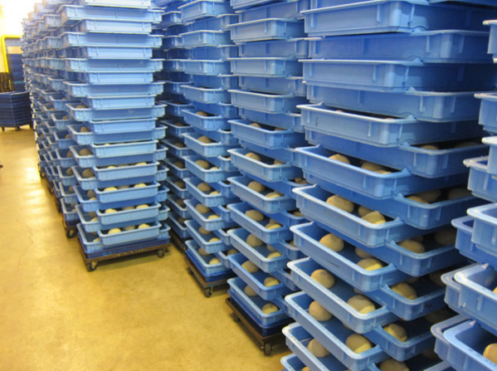

Figure 5: Stack of dough tray in distribution center

These distribution centers have the capacity to manufacture and distribute regular dough to meet the demand of the Domino’s stores they cover. Dough manufactured here will be stored in tray boxes on a rack inside refrigerated section of the distribution center before shipped to the stores (see Figure 5).

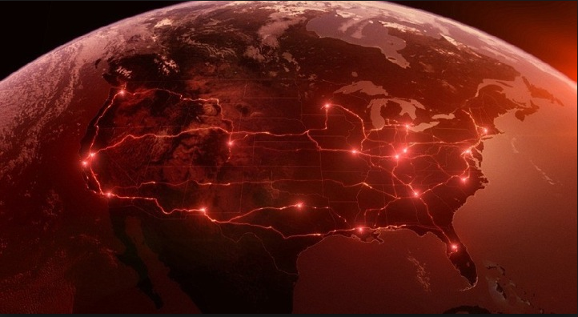

Figure 6: The 18 Domino’s distribution centers

Locations and capacities of each of the 16 Domino’s regional distribution centers (excludes the toppings, thin crust, and equipment centers) are given in the table below. Distribution center capacities are also given in pizza doughs per week with the distribution center being capable of manufacturing and redistributing ingredients to meet the pizza capacity. Distribution centers service stores twice a week with fresh pizza ingredients.

Table 1: Domino's distribution center location and dough supply capacity

| Distribution Center IDs | Address | Latitude | Longitude | Supply Capacity  (pizza/week) |
| --- | --- | --- | --- | --- |
| DC 1 | 17605 Commerce Dr.  New Boston, MI 48164 | 42.178616 | -83.391231 | 400,000 |
| DC 2 | 1638 Dolwick Dr.  Erlanger, KY 41018 | 39.056295 | -84.622101 | 350,000 |
| DC 3 | 8271 Anderson Ct  Odenton, MD 2111 | 39.096863 | -76.692468 | 450,000 |
| DC 4 | 3100 Waterfield Dr.  Garner, NC 27529 | 35.679414 | -76.543442 | 350,000 |
| DC 5 | 14 International Dr.  East Granby, CT 06026 | 41.927576 | -72.712023 | 250,000 |
| DC 6 | 4055 ROYAL DR NW,  KENNESAW, GA 3014 | 34.051791 | -84.607207 | 475,000 |
| DC 7 | 1 Cermak Blvd.  St. Peters, MO 63376 | 38.808893 | -90.642824 | 475,000 |
| DC 8 | 3355 Mike Collins Dr.  Eagan MN 55121 | 44.836107 | -93.131175 | 400,000 |
| DC 9 | 7600 American Way  Groveland, FL | 28.636731 | -81.828262 | 400,000 |
| DC 10 | 18251 E Petroleum Dr.  Baton Rouge, LA 70809 | 32.737928 | -97.020135 | 345,000 |
| DC 11 | 900 W Freeway St.  Grand Prairie, TX, 75051 | 32.737928 | -97.020135 | 350,000 |
| DC 12 | 10252 E 51st Ave.  Denver, CO 80238 | 39.790167 | -104.86922 | 350,000 |
| DC 13 | 5216 W Mohave St.  Phoenix, AZ 85043 | 33.431574 | -112.171835 | 300,000 |
| DC 14 | 8005 South 266th St # 101 Kent, WA 98032 | 47.362422 | -112.171751 | 475,000 |
| DC 15 | 30852 San Antonio St.  Hayward, CA 94544 | 37.615432 | -122.047669 | 500,000 |
| DC 16 | 301 South Rockefeller Ave.  Ontario, CA 91761 | 34.061151 | -117.553709 | 350,000 |

# Domino’s key suppliers

Domino's is one of the largest domestic bulk purchasers of pizza ingredients such as flour, cheese, sauce, and pizza boxes [8]. This allows Domino’s to maximize leverage with its suppliers. The main Domino’s pizza ingredients: cheese, flour, and tomato sauce are sourced from different suppliers. These ingredients will be delivered to each Domino’s distribution centers while retaining their quality standards. Domino’s 3 key suppliers are:

1. Leprino’s Foods
2. Paradise Tomato
3. Ardent Mills

## Dominos Cheese Supplier:

Cheese accounts for 26 to 40% of the pizza price for some companies [9]. Domino’s stores consume over 3.5 Million pounds of cheese per week. Domino’s purchases its mozzarella pizza cheese from a single supplier: Leprino Food Company [10]. Leprino has nine cheese supply locations throughout US with a total supply capacity of 6 million pounds of cheese per week to meet Domino’s and other cheese market demands. Cheese is shipped to each regional distribution center in 14 pound boxes. Each pizza uses 2 ¼ cups of cheese.

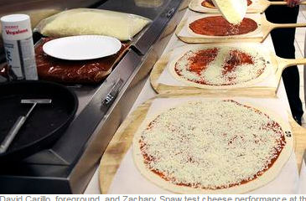

Leprino supplies quality controlled cheese to the 16 Domino’s distribution centers twice weekly. Detailed Leprino locations, supply capacity and the cost of a box of cheese are given in Table 2.

## Domino’s pizza tomato sauce supplier

The tomato sauce used by Domino’s pizza is supplied by Louisville, KY-based Paradise Tomato Kitchens [11]. Tomato sauce makes between 12- 16 percent of the total pizza ingredient cost. Each pizza uses 1 ½ cups of tomato sauce.

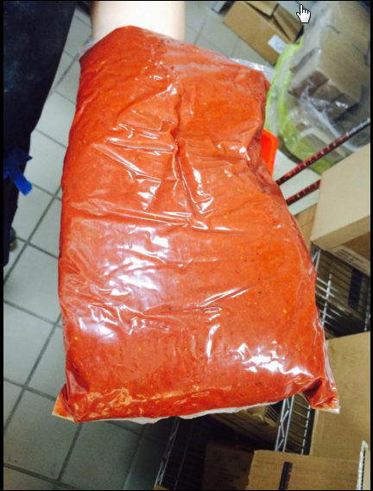

Paradise can supply up to 2.5 Million pounds per week of tomato sauce from its 3 location throughout US (see Table 2). Tomato sauce is shipped to the regional distribution centers in 42 pound boxes.

Figure 7: Pouch of Paradise tomato sauce

## Domino’s flour supplier

Ardent Mills is one of the largest flour producing company in US. Ardent mills have 44 milling locations in USA and Canada [12]. 38 of these sites are in the US. It costs Ardent Mills $750,000 to tool a mill to grind flour to Domino’s exacting standards. Each pizza uses 3 cups of flour. Ardent Mills delivers it flour to Domino’s regional distribution centers in 50 pound sacks.

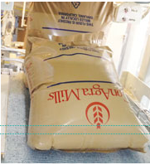

Figure 9 : Ardent Mill 50 lb. flour

## Suppliers information

The following tables provide list of all 51 suppliers in tier1 with their geographical location and other important data.

Table : List Domino’s suppliers [13, 14]

| Store | Address | Latitude | Longitude | Supply Capacity (Unit/week) | Cost per unit ($) |
| --- | --- | --- | --- | --- | --- |
| Leprino 1 | 5600 Omaha Rd  Roswell NM 88203 | 33.331665 | -104.481049 | 42,857 | 6.46 |
| Leprino 2 | 1302 1st Ave  Greeley CO | 40.416795 | -104.675733 | 42,857 | 6.46 |
| Leprino 3 | 400 Rino Ave  Waverly, NY 14892 | 42.010352 | -76.527166 | 60,000 | 6.16 |
| Leprino 4 | 217 Yanuzzi Dr.  Sayre, PA 18840 | 41.99911 | -76.543442 | 42,857 | 7.96 |
| Leprino 5 | 311 N Sheridan Rd  Remus, MI 49340 | 43.594649 | -85.145349 | 38,571 | 7.96 |
| Leprino 6 | 4700 Rich St  Allendale, MI 49401 | 42.978232 | -85.900823 | 51,429 | 6.16 |
| Leprino 7 | 2400 E Beaver Ave  Fort Morgan, CO 80701 | 40.251095 | -103.763711 | 60,000 | 6.46 |
| Leprino 8 | 2401 N MacArthur Dr, Tracy, CA 95376 | 37.755378 | -121.41575 | 47,143 | 7.96 |
| Leprino 9 | 351 Belle Haven Dr, Lemoore, CA 93245 | 36.300217 | -119.821594 | 42,857 | 6.97 |
| Paradise 1 | 1500 S Brook St, Louisville, KY 40208-1950 | 38.224893 | -85.755722 | 10,416 | 12.01 |
| Paradise 2 | 13448 VOLTA RD, LOS BANOS, CA, 936359785, | 37.093404 | -120.920486 | 11,012 | 10.6 |
| Paradise 3 | 1600 Crums ln. Louisville, KY 40216-3826 | 38.188715 | -85.805683 | 8,333.0 | 11.31 |
| Ardent 1 | 4545 E 64th Ave. Commerce City, CO 80022 | 39.81372 | -104.933875 | 7,200 | 35.71 |
| Ardent 2 | 19684 Cajon Blvd  San Bernardino, CA 92407 | 34.198522 | -117.3756 | 11,200 | 34.93 |
| Ardent3 | 1900 Industry Dr. Culpeper, VA 22701 | 38.451794 | -77.989321 | 11,200 | 34.27 |
| Ardent4 | 2050 Market Street NE Decatur, AL 35601 | 34.600933 | -86.958413 | 8,000 | 34.74 |
| Ardent5 | 3939 Producers Dr. Stockton, CA 95206 | 37.9086 | -121.271413 | 11,200 | 35.9 |
| Ardent6 | 200 N Riverfront Dr. Mankato, MN 56001 | 44.16864 | -94.001903 | 9,600 | 34.51 |
| Ardent7 | 1521 N 16th St.  Omaha, NE 68110 | 41.27389 | -95.936973 | 11,200 | 34.52 |
| Ardent8 | 2800 Black Bridge Rd. York, PA 17406 | 40.002684 | -76.711711 | 12,800 | 36.12 |
| Ardent9 | 21151 SW 115th Ave, Tualatin, OR 97062 | 45.366716 | -122.796368 | 12,400 | 35.71 |
| Ardent10 | 2020 E Steel Rd  Colton, CA 92324 | 34.061765 | -117.292624 | 7,200 | 34.68 |
| Ardent11 | 2780 G Ave,  Ogden, UT 84401 | 41.215179 | -111.997595 | 11,200 | 35.71 |
| Ardent12 | 3750 Wynkoop St. ,Denver, CO 80216 | 39.771424 | -104.975535 | 8,800 | 35.01 |
| Ardent13 | 9345 Highway 127 Fairmount, ND 58030 | 46.059036 | -96.617257 | 8,000 | 35.68 |
| Ardent14 | 1100 S Main St.  Galena Park, TX | 29.732225 | -95.237361 | 11,200 | 36.23 |
| Ardent15 | 401 E Industrial Blvd,  Saginaw, TX 76179 | 32.849152 | -97.35746 | 9,600 | 34.52 |
| Ardent16 | 408 E Magnolia St Sherman, TX 75090 | 33.63354 | -96.604075 | 11,200 | 36.72 |
| Ardent17 | 715 E 13th St,  Wichita, KS 67214 | 37.707825 | -97.328948 | 12,800 | 35.71 |
| Ardent18 | 300 East Broadway Newton, KS 67114 | 38.049903 | -97.341255 | 12,400 | 35.35 |
| Ardent19 | 2900 C St.  Omaha, NE 68107 | 41.223361 | -95.954189 | 12,400 | 35.71 |
| Ardent20 | 125 S Broad St.  Fremont, NE 68025 | 41.429638 | -96.49984 | 11,200 | 34.21 |
| Ardent21 | 905 W Marion St.  Lake City, MN 55041 | 44.441653 | -92.271379 | 8,800 | 36.72 |
| Ardent22 | 2005 Vermillion St.  Hastings, MN 55033 | 44.727164 | -92.852107 | 8,000 | 36.22 |
| Ardent23 | 15407 McGinty Rd  West Wayzata, MN 55391 | 44.952234 | -93.477248 | 11,200 | 35.52 |
| Ardent24 | 254 South Bremer Ave. Rush City, MN 55069 | 45.686504 | -92.962419 | 9,600 | 36.58 |
| Ardent25 | 1843 Highway 1 South Port Allen, LA 70767 | 30.436028 | -91.209739 | 11,200 | 35.71 |
| Ardent26 | 101 Water St. Chester, IL 62233 | 37.893441 | -89.816971 | 12,800 | 34.52 |
| Ardent27 | 145 W Broadway St Alton, IL 62002 | 38.890354 | -90.186933 | 12,400 | 35.71 |
| Ardent28 | 6509 77th Ave. Kenosha, WI 53142 | 42.575812 | -87.899285 | 7,200 | 34.78 |
| Ardent29 | 1B Riverside Lane Chattanooga, TN 37406 | 35.082238 | -85.273314 | 11,200 | 35.71 |
| Ardent30 | 4200 Sullivant Ave. Columbus, OH 43228 | 39.94394 | -83.108152 | 8,800 | 34.92 |
| Ardent31 | 945 Mill Road Loudonville, OH 44842 | 40.645688 | -82.241162 | 8,000 | 35.71 |
| Ardent32 | 4828 S Delaware Dr Easton, PA 18040 | 40.760557 | -75.185281 | 8,800 | 35.71 |
| Ardent33 | 321 E Breadfruit Dr.  Treichlers, PA 18086 | 40.736004 | -75.543861 | 20,000 | 35.55 |
| Ardent34 | Route 940 & Harvest Ln. Mount Pocono, PA 18344 | 41.111362 | -75.38177 | 11,200 | 36.01 |
| Ardent35 | 101 Normanskill St. Albany, NY 12202 | 42.619044 | -73.763883 | 12,800 | 34.29 |
| Ardent36 | 35 Nemco Way Ayer, MA 01432 | 42.565811 | -71.53271 | 12,400 | 35.88 |
| Ardent37 | 211 Lower Poplar St.Macon, GA 31201 | 32.829522 | -83.620771 | 1,750 | 33.95 |
| Ardent38 | 15000 Shutler Dr. Arlington, OR 97812 | 45.716796 | -120.200876 | 20,000 | 34.92 |

## Domino’s Suppliers to Domino’s distribution center

For this case study assume that each store is on a dedicated supply route – that is, if a truck is dispatched to supply a store from a distribution center, it will go from the regional distribution center to the store, and then return to the regional distribution center. While not a valid assumption for how it really works, it is a valid assumption for “clustering” the stores around the optimal set of regional centers. If we wanted to be more realistic in our algorithm, we would do a vehicle routing problem which is far too complex for this course. Assume a store is supplied twice a week. Use 4 days in a “half week” to make the math work out.

## Transportation cost

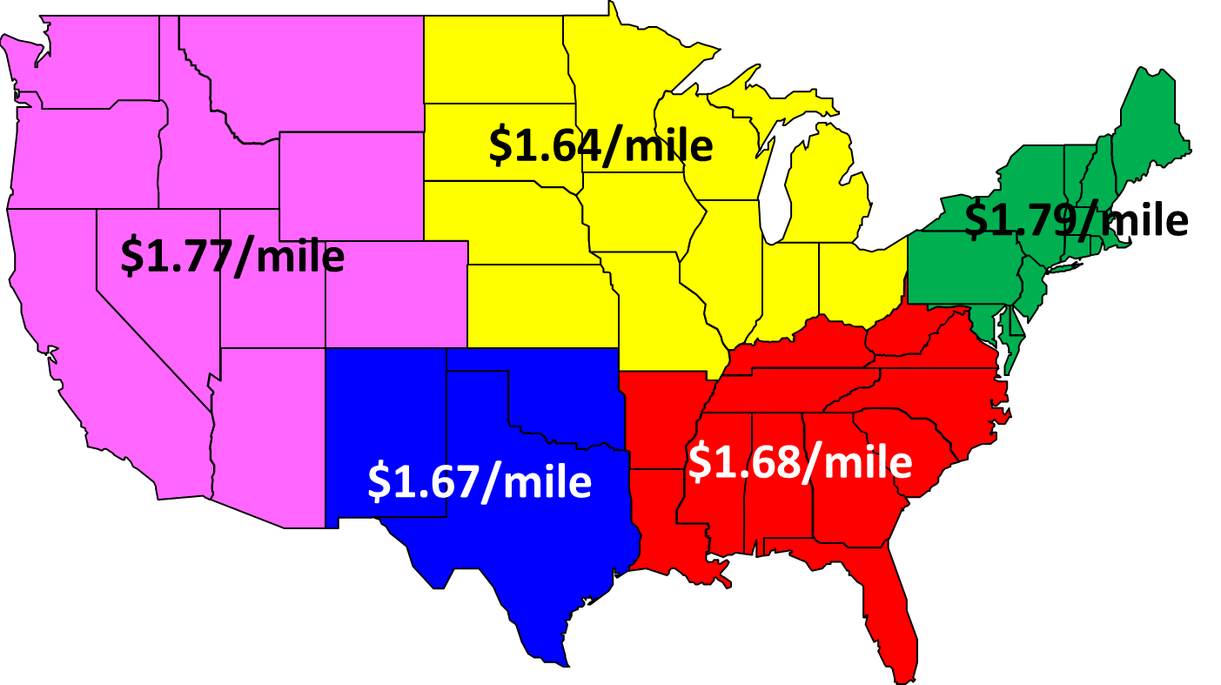

Figure 9: Regional division of United States

The average marginal Cost per mile for each region in United States is adapted from “*An Analysis of the Operational Costs of Trucking: A 2015 Update*” [15]. Assume the cost of transportation is driven by the location of the regional distribution center.

Table 3: Marginal cost of transportation per mile

|  |  |  |  |  |
| --- | --- | --- | --- | --- |
| Average Marginal Cost per Mile by Region, 2014 | | | | |
| Midwest | Northeast | Southeast | Southwest | West |
| $1.64 | $1.79 | $1.68 | $1.67 | $1.77 |

# Bibliography

[1] Hynam, Rick, Pizza Power Report 2017 – A state of the Pizza Industry Report, Pizza Magazin Quarterly, December 2016, <http://www.pmq.com/December-2016/Pizza-Power-2017-A-State-of-the-Industry-Report/> *(accessed 11 FEB, 2017)*

[2] “The Pie That Conquered America - The First Pizzeria in the United States”, <http://pizza.com/the-first-pizzeria-in-the-united-states>, *(accessed 11 FEB 2017)*

[3] Pizza Hut Inc. History, Funding Universe, [http://www.fundinguniverse.com/company-histories/pizza-hut-inc-history /](http://www.fundinguniverse.com/company-histories/pizza-hut-inc-history%20/) *(accessed 11 FEB 2017)*

[4] Hynum, Rick, “*The 2015 Pizza Power Report*” <http://www.pmq.com/December-2014/Pizza-PowerThe-2015-Pizza-Power-Report/,December,2014>

[5]Metcalf, Thomas, “How Much Profit Margin in Pizza?” Chron, <http://smallbusiness.chron.com/much-profit-margin-pizza-62139.html> *(accessed 11 FEB 2017)*

[6]. Domino’s, Inc, History, Funding Universe, <http://www.fundinguniverse.com/company-histories/domino-s-inc-history/> *(accessed 11 FEB 2017)*

[7] Domino’s Pizza Inc, *“Making Pizza since 1960…*”, <https://biz.dominos.com/web/about-dominos-pizza/history> *(accessed 11 FEB 2017)*

[8] “*Form 10-k*”, United States Securities and Exchange Commission, February 25, 2016, <https://www.sec.gov/Archives/edgar/data/1286681/000119312516476935/d128680d10k.htm#tx128680_11>

[9]. "*Why Domino’s Pizza is Not Worried About Rising Cheese Prices*" <http://www.fastfoodmenuprices.com/dominos-pizza-worried-rising-cheese-prices/>, September 14, 2014 *(accessed 11 FEB 2017)*

[10] Tice, Carol, *“Cruel Cheese: Pizza Chains Condemn Supplier’s Animal Abuse…Again”*, <http://www.forbes.com/sites/caroltice/2014/09/17/cruel-cheese-pizza-chains-condemn-suppliers-animal-abuse-again-video/#16ec03663918> (accessed 11 FEB 2017)

[11]. Paradise Tomato Kitchens, *“Domino’s Recognizes Paradise With Supplier of the Year Award”*, <http://www.paradisetomato.com/article-press-release.aspx?id=66>, *(accessed 11 FEB 2017)*

[12] Schroeder, Eric, “*Domino’s, Ardent Mills pizza partnership still strong*” <http://www.bakingbusiness.com/articles/news_home/Business/2015/06/Dominos_Ardent_Mills_pizza_par.aspx?ID=%7BEF3E37FE-D104-4001-973D-A266C8974E2D%7D&cck=1>, *(accessed 11 FEB 2017)*

[13] “*Leprino’s Food location*”, . <http://www.leprinofoods.com/locations/denver-colorado/> *(accessed 11 FEB 2017)*

[14] “Ardent Mills Locations”, <http://www.ardentmills.com/communities/locations.html>, *(accessed 11 FEB 2017)*

[15]. "An Analysis of the Operational Costs of Trucking: A 2015 Update", American Transportation Research Institute, September 2015, <http://atri-online.org/wp-content/uploads/2015/09/ATRI-Operational-Costs-of-Trucking-2015-FINAL-09-2015.pdf>, *(accessed 11 FEB 2017)*.